***Week 3***

**Assignment #1: Shoe Drawing**

As many of you might remember, right before we left school, we were creating our own Shoe Drawings. We’re going to pick up here.

**Part 1:** Using whatever materials you have at home, ***create a drawing of a shoe***. Pencil, Pen, Marker, Crayons, Paint, Colored Pencil… Any medium is acceptable! Lined paper is fine too if that’s what you have!



1. Start by choosing your shoe. Now this shoe could be any style, any brand, whatever you like.
2. Find a reference to draw from. That could either be a real shoe set up in front of you like a still-life, or a reference photo that you find online.
3. Sketch lightly first, and then add any and all details.
4. Add color or shading!

If you check out my Instagram ( @swiateks_artroom ) you will see some examples that I posted! Including a video of me drawing my own shoe.

**Part 2:** Take 1 photo of your drawing, and send it to me through REMIND or my school email @ [cswiatek@nfschools.net](mailto:cswiatek@nfschools.net)

**BE SURE TO INCLUDE YOUR NAME AND**

**CLASS PERIOD IN THE EMAIL!!!**

**DUE FRIDAY 5/1**

**Examples:**

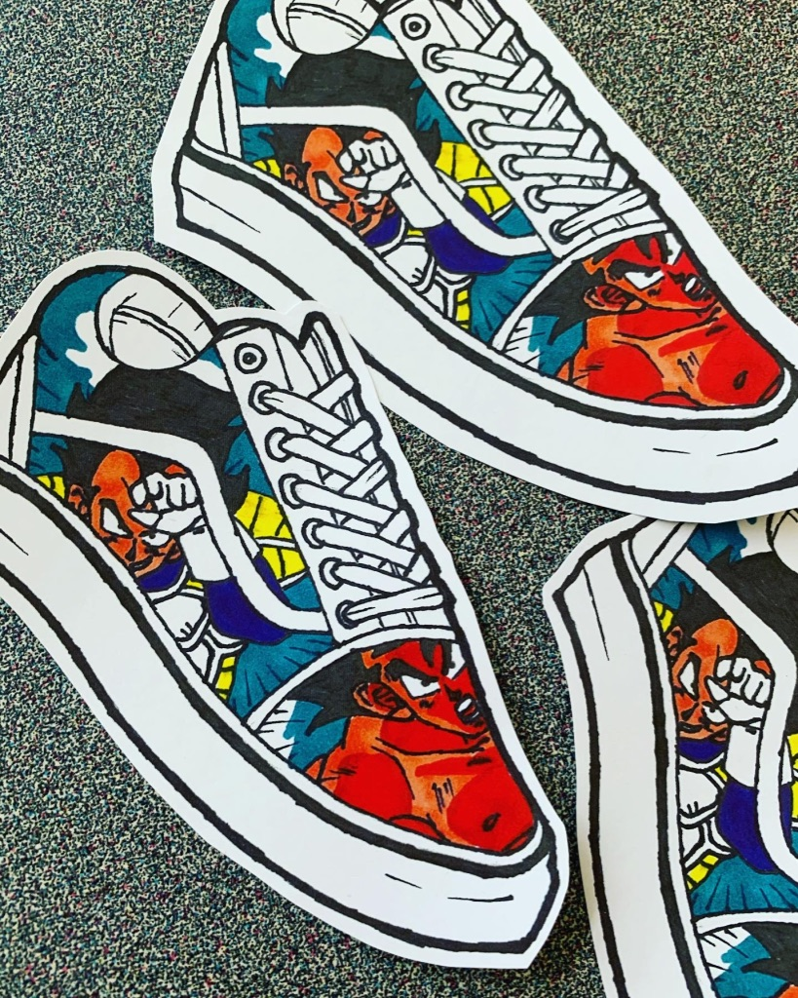 

**TIPS:**

* Make sure that you are looking at a real shoe, or a picture of a shoe (reference photo).
* Have fun and design your shoe for you!
* When taking your photo, find good lighting and zoom in.

*Note:* Some of you have already completed this assignment. If so, use this time to get your next assignment done. If you don’t see a grade by Wednesday, 4/28, shoot me a message on Remind.